

Guidelines for completing an application for IDA Ireland RD&I Grant Support

Contents

1 Introduction 1

1.1 Background 1

1.2 Aims of RD&I Grant Aid 1

1.3 Form of Aid 2

2 Eligible Projects 2

2.1 Applicant Eligibility 2

2.2 RD&I Project Definition 2

2.3 Eligible Activities 3

2.4 Ineligible Activities 3

2.5 Applications Consisting of Multiple Projects and/or Multiple Work packages 4

3 Application Process 5

3.1 Initial Engagement & Application Forms 5

Assessment Process 6

3.2 External Technical Assessment 6

3.3 IDA Ireland Assessment 7

3.4 Environmental Impact of the Project 8

3.5 Timeframe 9

3.6 Implementation of Approved PROJECTS 9

4 Eligible Costs 10

4.1 A: Personnel costs: researchers, technicians and other supporting staff to the extent employed on the project. 11

4.2 B: Costs of instruments and equipment 12

4.2.1 Depreciation of Instruments and Equipment: 12

4.2.2 Depreciation of ICT Capital Costs: 13

4.3 C: Costs of Buildings & Land 13

4.4 D: Costs of contractual research, knowledge and patents, consultancy and equivalent services (e.g contract R&D) 13

4.5 E: Additional overheads and other operating expenses (including materials supplies and similar products) 15

4.5.1 Treatment of Materials Costs 15

5 Intellectual Property Management 15

6 Repeat Applications 15

7 EU State Aid 16

7.1 Legal Basis 16

7.2 State Aid Basis 16

7.3 Demonstrating the Need for State Intervention 16

7.4 Demonstrating the Incentive Effect 18

# Introduction

## Background

The IDA Ireland grant for Research, Development & Innovation (RD&I) is part of a national RD&I support program aimed at developing and significantly increasing company engagement in RD&I activity in line with the objectives set out in the government White Paper on Enterprise 2022-2030.

Companies establishing or substantially expanding their existing Irish RD&I function can avail of this financial incentive to carry out **in-house RD&I projects** and **collaborative projects** with third-level institutes and industrial partners.

It is intended that, through this financial support, companies will be encouraged to grow competitively by increasing their research, development, and technical innovation activities and that the quality and quantity of RD&I linkages between companies both nationally and internationally will be increased. Specifically, IDA Ireland envisages that companies utilising this RD&I grant aid will be aiming towards achieving the following:

* Increased strategic relevance of the Irish operation within the corporate group structure.
* A significant, ongoing/established RD&I budget.
* A demonstrable connection between RD&I activity and commercial outputs.
* An established RD&I team with high level skills.
* High quality facilities for RD&I.
* Formation of robust RD&I quality management systems.
* Position the Irish operation optimally to win future higher value/more strategic investments with potential for economic impact.
* Develop a culture of innovative thinking throughout the company which aims to harness the creativity of all the staff towards defined business goals.

These guidelines are intended to assist the client in the completion of the RD&I application forms for grant aid from IDA Ireland.

## Aims of RD&I Grant Aid

The aims of the RD&I grant aid are to:

* Help manufacturing and service firms develop innovative products, processes, and services.
* Increase the number of companies performing RD&I in Ireland.
* Increase the scale of the investment in RD&I in Irish operations.
* Increase the number of companies in Ireland doing RD&I for the first time.
* Ensure Irish based companies protect their futures by helping them reach and exceed European and international norms for RD&I investment.
* Increase the quantity and quality of the RD&I linkages between companies and academia, either in Ireland or internationally, through collaborative research programmes.

## Form of Aid

Funding will be in the form of an RD&I grant which will be a percentage of the overall eligible costs of the project, the percentage is determined on a case-by-case basis by IDA Ireland. The grant will be paid by IDA Ireland retrospectively following completion of agreed milestones, as outlined by the company in the client application form and agreed in the subsequent legal agreement on terms and conditions of the grant.

# Eligible Projects

## Applicant Eligibility

The RD&I grant is open to application by existing and potential clients of IDA Ireland.

The programme can also support B-2-B [1] collaborations (MNC-MNC and MNC-SME[2]). In the case of companies where there is collaboration between companies in different countries, only the eligible RD&I costs of the Irish based activity will be considered for support under this RD&I grant. In all cases, each applicant company in the collaboration must independently complete a full RD&I grant application.

## RD&I Project Definition

A 'RD&I project' means an operation that includes activities spanning over industrial research or experimental development (see section 2.3), and that is intended to accomplish an indivisible task of a precise economic or technical nature with clearly pre-defined goals.

For grant aid purposes, RD&I projects must satisfy the following criteria:

* Are an integral part of the strategic development plans of the company rather than routine developments.
* Contribute to a sustained process of innovation within the company.
* Have well defined plans to commercialise the results of the RD&I (typically within one year of completion of the project).
* Represent an advance in the level of technical innovation relative to the company’s current products/processes.
* Are designed to help the company meet market requirements, especially in the area of higher added value products with increased functionality and benefits.
* Clearly show how companies plan to undertake the project, particularly in relation to the resources required to develop the project.

## Eligible Activities

RD&I projects that can be defined as experimental development or industrial research are eligible for support. Projects may contain one or more of these categories i.e., it may share elements of experimental development and industrial research. A description of each category is given below.

**Note:** For RD&I grants that seek to develop digital products, processes or services, in any area, technology, industry or sector (including, but not limited to, digital industries and technologies, such as for example super-computing, quantum technologies, block chain technologies, artificial intelligence, cyber security, big data and cloud or edge technologies), please discuss the project with your IDA Project Executive before you start the application process as your application may require an alternative suite of application documents.

**RD&I: Experimental Development****:** means acquiring, combining, shaping and using existing scientific, technological, business and other relevant knowledge and skills with the aim of developing new or improved products, processes or services, including digital products, processes or services, in any area, technology, industry or sector (including, but not limited to, digital industries and technologies, such as for example super-computing, quantum technologies, block chain technologies, artificial intelligence, cyber security, big data and cloud or edge technologies).

This may also encompass, for example, activities aiming at the conceptual definition, planning and documentation of new products, processes or services. Experimental development may comprise prototyping, demonstrating, piloting, testing and validation of new or improved products, processes, or services in environments representative of real-life operating conditions where the primary objective is to make further technical improvements on products, processes or services that are not substantially set.

This may include the development of a commercially usable prototype or pilot which is necessarily the final commercial product, and which is too expensive to produce for it to be used only for demonstration and validation purposes. Experimental development does not include routine or periodic changes made to existing products, production lines, manufacturing processes, services and other operations in progress, even if those changes may represent improvements.

**Industrial Research**: means the planned research or critical investigation aimed at the acquisition of new knowledge and skills for developing new products, processes or services or aimed at bringing about a significant improvement in existing products, processes or services, including digital products, processes or services, in any area, technology, industry or sector (including, but not limited to, digital industries and technologies, such as super-computing, quantum technologies, block chain technologies, artificial intelligence, cyber security, big data and cloud technologies). Industrial research comprises the creation of components parts of complex systems, and may include the construction of prototypes in a laboratory environment or in an environment with simulated interfaces to existing systems as well as of pilot lines, when necessary for the industrial research and notably for generic technology validation

## Ineligible Activities

It is not the aim of this initiative to fund routine or periodic changes to products, production lines, manufacturing processes, existing services, and other operations in process, even if such changes may represent improvements. Projects involving routine transfer of well-established technology to a new site are not eligible for RD&I grant aid unless a case can be made that significant technical uncertainty must be addressed.

## Applications Consisting of Multiple Projects and/or Multiple Work packages

An application for RD&I grant aid may consist of one or more RD&I projects (as defined in section 2.2). Each RD&I project may contain multiple work packages.

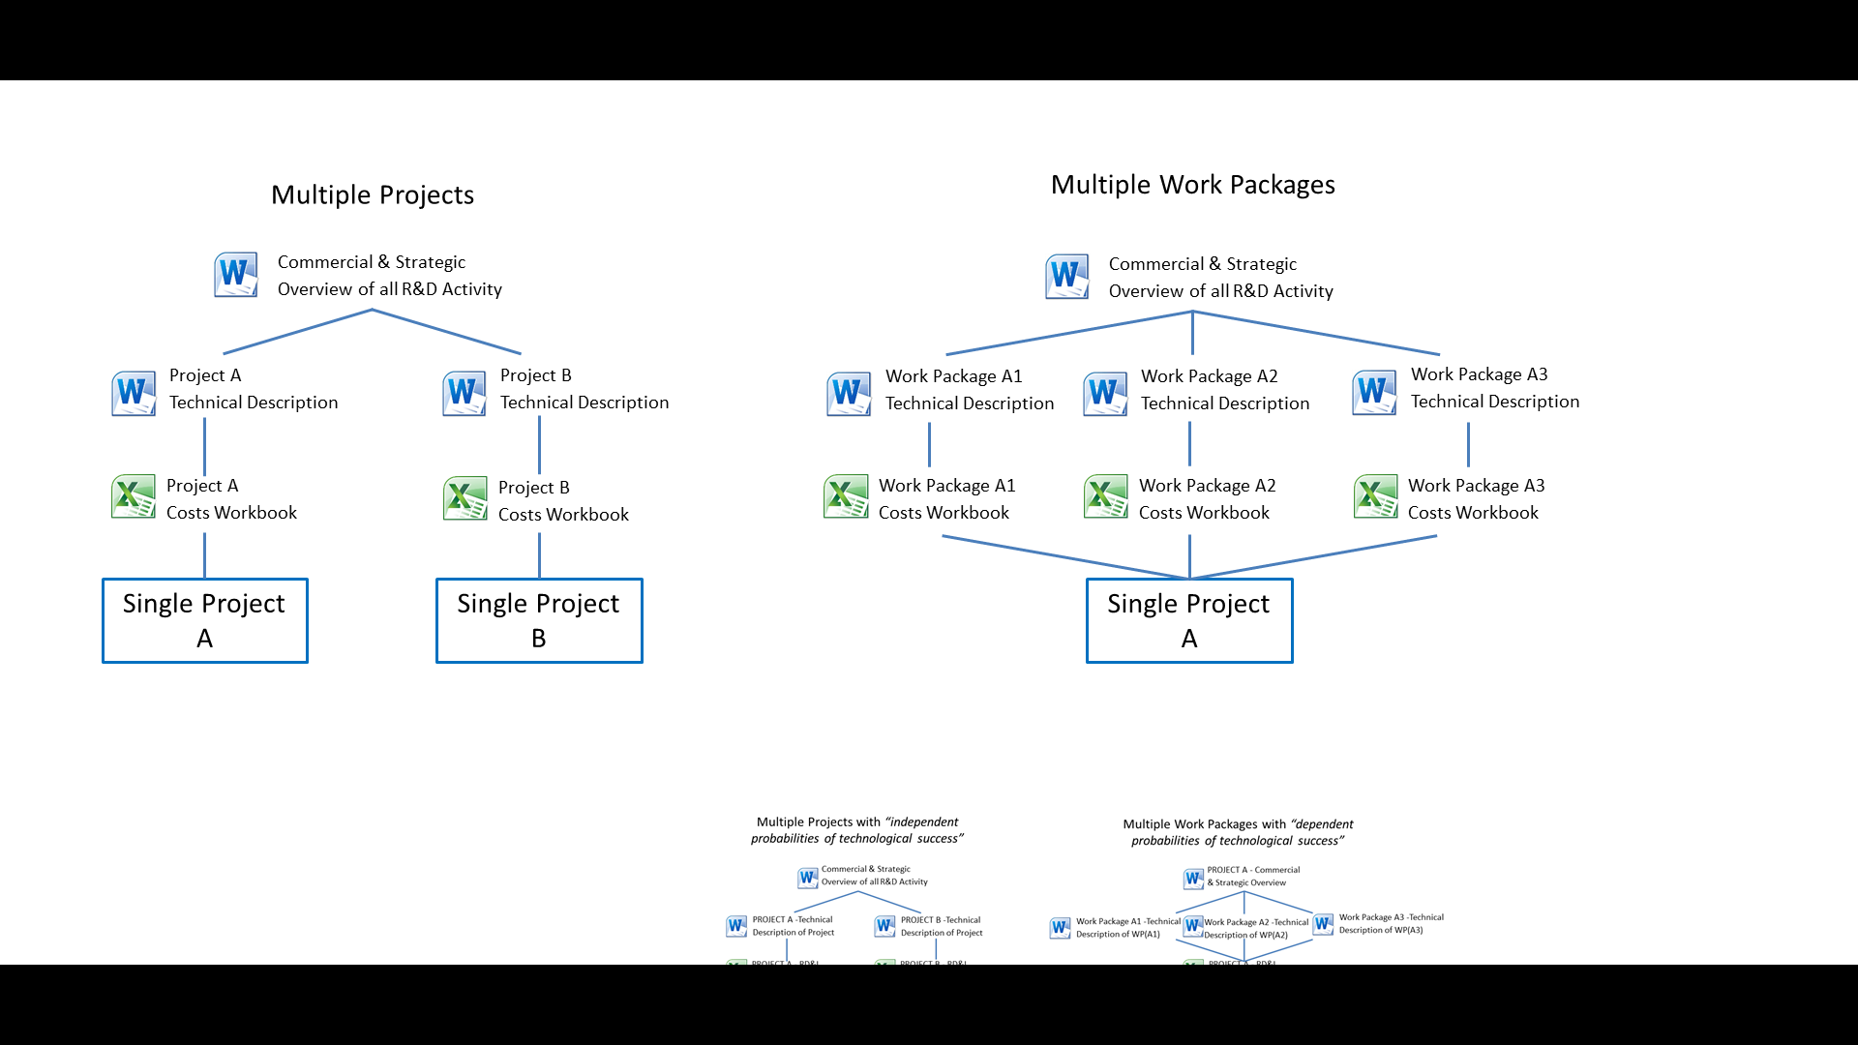

Figure 1 - Multiple Projects V's Multiple Work Packages

F**igure 1** shows how the application forms should be used when there are multiple projects and/or multiple work packages.

**Multiple Projects**

When two or more RD&I projects are clearly separable from each other (and when they have **independent probabilities of technological success**), they are considered multiple single projects. Multiple approved projects are covered **under one grant agreement**. There is no mechanism to transfer costs between projects if one was under-estimated and another over-estimated.

**Multiple Work Packages**

A RD&I project may consist of several work packages that aim to achieve one or more of the project objectives. For applications with multiple work packages **the interdependence of each work package, technical and/or economic, should be clearly described** in the Commercial & Strategic Overview document (under “Overview & Scope of Proposed RD&I Activity”).

Please consult with your IDA Executive who can guide you on how best to categorise your proposed activity if there is any uncertainty.

# Application Process

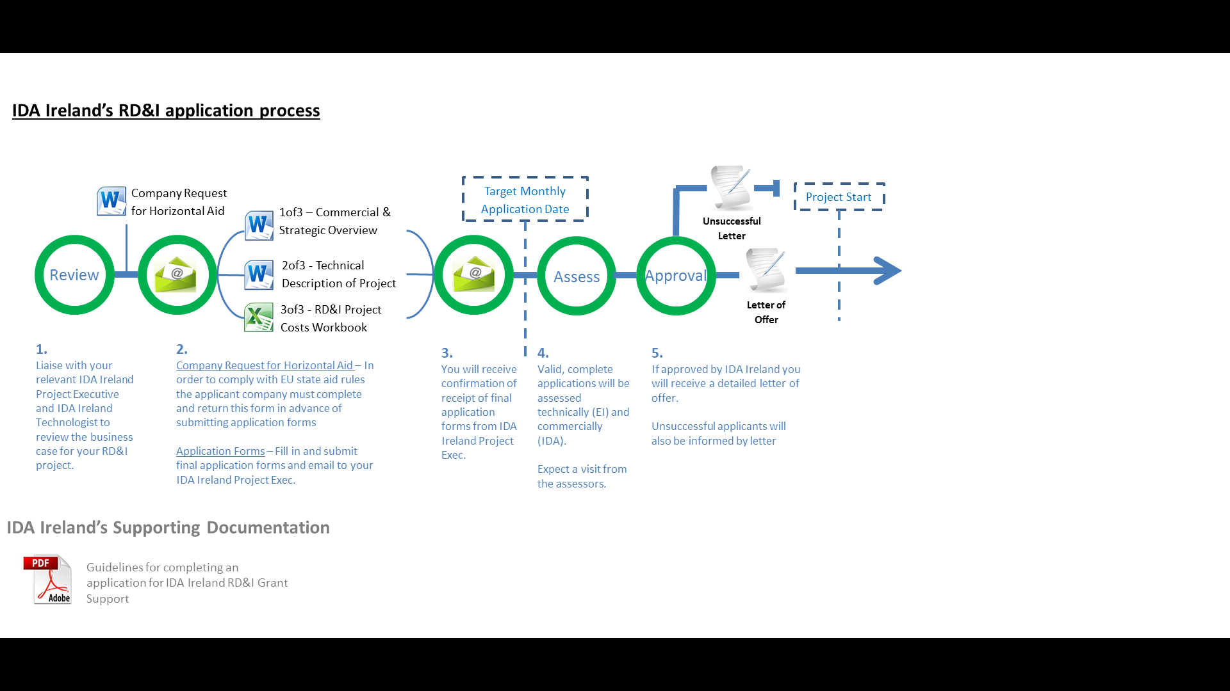

Figure 2 - IDA Ireland's RD&I application process

**Figure 2** above details the different stages of the application process. The RD&I grant application process can be broken down into three distinct phases: engagement & application forms (section 3.1), assessment (section 3.2) & approval (section 3.3).

## Initial Engagement & Application Forms

Prior to completing any forms, a company should discuss the proposed RD&I activity in detail with their relevant IDA Ireland Project Executive and IDA Ireland Technologist. It is important to include the IDA Technologist early in these discussions.

To formally initiate the process the company needs to complete the ‘Request for Horizontal Aid’ form and return it to IDA Ireland in advance of completing application forms.

The application has several forms, which are listed in Table 1.

|  |  |
| --- | --- |
| **FORM** | **DESCRIPTION** |
| **1 of 3 – Commercial & Strategic Overview of Proposed Activity** | This form should be filled in by a person with commercial knowledge of the company and the markets that they operate in (e.g., MD, Financial Officer, Business Development). The purpose of this form is to set the commercial and strategic context for the RD&I activity. The information provided enables IDA Ireland to assess how the RD&I activity is an integral part of the strategic development plan of the company and the potential for commercial return. These are both key elements when determining the funding decision and funding amount. |
| **2 of 3 - Technical Description of Project** | This form should be filled in by a technical person in the company, ideally the technical lead on the project. The purpose of this from is to provide a detailed technical description of the project and to capture the various project planning elements required to successfully deliver the required outcome. The external Technical Assessor (Enterprise Ireland) will use this technical document to establish whether the activity is sufficiently “innovative” and “risky” to warrant public investment support.  It is critical that the RD&I project contains sufficient technical detail on the approach, technical uncertainties and risks- the guidelines should be consulted before submission to avoid application rejection by the external assessor. |
| **3 of 3 - RD&I Project Costs Workbook** | This spreadsheet is used to capture the costings for the proposed RD&I Project. For more details on the eligible costs and costing models used, refer to section 4 below. The external Technical Assessor will use this document to ensure eligible costs are aligned with comparable industry norms. |

Table 1 - Documentation required for RD&I application.

The application can be held in draft form for discussions and revision until the client is satisfied it reflects the work program proposed and IDA Ireland are satisfied that all required information is present.

The documents should then be submitted to the dedicated IDA Ireland Project Executive via email. The application will not be processed until all sets of documentation are received by IDA Ireland. The applicant will receive an email to acknowledge receipt of supporting documentation with guidance on next steps and timelines if not already discussed and agreed.

## Assessment Process

## External Technical Assessment

The IDA Project Executive will assign an independent technical assessor to evaluate the project. That person will be under strict non-disclosure terms and is usually either a Technologist from another state agency (Enterprise Ireland) or an academic from an Irish University.

The goals of the technical assessment process are to.

1. Establish the eligibility of the project for funding support with reference to EU state aid regulations (see section 7).
2. Provide a technical assessment report to the IDA as input to the IDA Management Investment Committee in making the funding decision.
3. Determine the project costs that are eligible for grant support.

The assessor will look to set up a meeting with one or more **technical staff** from the applicant company to review the project plan. The normal agenda of a technical assessment is as follows.

* Understand current RD&I activity.
* Review the overall goal of the proposed RD&I activity and the technical approach.
* Review the technical activities and the challenges involved.
* Discuss the innovative aspects of the project and the resources need for successful delivery.
* Understand the expected outputs and the plans towards commercialisation of RD&I outputs.

The face-to-face meeting format is an informal technical discussion rather than a PowerPoint presentation. A demonstration or tour of existing operations may be appropriate to give context.

The assessor will also want to talk through the project costs. This is often done with members of the company’s finance team and could be done either as part of the same technical assessment meeting or as a separate meeting.

After the meeting(s), there may be updates required to the project plan and/or costs to be sent to the technical assessor as input to his/her report. The technical assessor will submit an evaluation report to the IDA establishing the eligibility or otherwise of the project and providing a comment to the IDA on the ‘technical quality’ of the project as well as a determination of the allowed project costs.

**Note:** The external technical assessor will be looking for a clear demonstration that the RD&I activity proposed represents a technical uplift for the site.

## IDA Ireland Assessment

The IDA Ireland approving committee/authority in making its decision on a Company’s funding rate, will take into account an assessment of the technical, commercial and financial merits of the project as well as the need for state intervention (section 7.3) and the incentive effect of the grant aid (section 7.4). The approving committee/authority will be presented with an assessment of the project by the IDA Project Executive, which incorporates commentary on the following assessment criteria:

* Value for money for the State considering the performance against targets set in previous investments, the quality of this project compared to previous RD&I projects and the overall amount of State funding received by the company in the last seven years.
* How the proposed activities are additional to the current level of RD&I activities and lead to a sustainable increase in RD&I as a % of sales.
* How the RD&I plan is an integral part of the strategic development plan of the company.
* Financial track record of the company.
* Development needs of the company.
* Previous track record in implementing previous State funded RD&I projects (if any).
* The increase in RD&I capability within the company.
* Technical feasibility of completing the project.
* Quality of project planning and costing.

Additional information will be required by the IDA Project Executive upon submission of application forms to supplement the assessment of your application by IDA Ireland, this includes:

* The company’s most recent audited and management accounts (P&L and Balance Sheet) should be forwarded with the application.
* Detailed group structure (if applicable).
* Full company financial projections and cashflow projections.

## Environmental Impact of the Project

* Describe how the project will impact on GHG emissions in Ireland.
* State whether the company falls under the Emissions Trading System (ETS).
* Provide projections on energy and resource use associated with the project in Ireland- complete Environmental Impact Tab in the Project Cost Workbook.
* Note: Please provide base year amounts and **projected yearly** increases or decreases in energy and resource use **as a result of project activity.** Information can be supplied in € amounts or units used for most categories.

**Projected Energy and Resource Use\***

|  |  |  |  |  |  |  |  |
| --- | --- | --- | --- | --- | --- | --- | --- |
| **Category** | **Description** | **Base Yr** | **Year 1** | **Year 2** | **Year 3** | **Year 4** | **Year 5** |
| **Natural Gas** | € |  |  |  |  |  |  |
| Kwh |  |  |  |  |  |  |
| **Heating Oil** | € |  |  |  |  |  |  |
| Litres |  |  |  |  |  |  |
| **LPG** | € |  |  |  |  |  |  |
| Litres |  |  |  |  |  |  |
| **Electricity** | € |  |  |  |  |  |  |
| Kwh |  |  |  |  |  |  |
| **Heavy Fuel Oil** | € |  |  |  |  |  |  |
| Litres |  |  |  |  |  |  |
| **Coal** | € |  |  |  |  |  |  |
| Tonnes |  |  |  |  |  |  |
| **Kerosene** | € |  |  |  |  |  |  |
| Litres |  |  |  |  |  |  |
| **Petrol\*\*** | € |  |  |  |  |  |  |
| Km |  |  |  |  |  |  |
| **Diesel \*\*** | € |  |  |  |  |  |  |
| Km |  |  |  |  |  |  |
| **No. Business Flights (EU/UK)** | Total number of flights taken by employees for business related activities |  |  |  |  |  |  |
| **No. Business Flights (Non-EU/UK)** | Total number of flights taken by employees for business related activities |  |  |  |  |  |  |
| **Black Bin (Kg)** | Volume of black bin waste |  |  |  |  |  |  |
| **Brown Bin (Kg)** | Volume of brown bin waste |  |  |  |  |  |  |
| **Water Usage (m3)** | Volume of business water usage |  |  |  |  |  |  |

**\***Input either volume or cost for selected categories. **Cost or business mileage of commercial vehicles

## Timeframe

Applications are processed monthly. The typical approval time frame from target monthly application date to a project being presented at committee is dependent on the grant amount and is detailed in Table 2:

|  |  |  |
| --- | --- | --- |
| **Grant Amount** | **Approval By** | **Typical Timeframe** |
| Greater than €7.5m. | Government | 8-12 weeks |
| €900,000 to €7.5m | The IDA Ireland Board | 6-10 weeks |
| Up to €900,000 per project. | The IDA Ireland Management Investment Committee (MIC) | 4-8 weeks |

Table 2 - Typical RD&I time frame from monthly call close to approval decision.

All applications will be subject to a technical assessment by an independent assessor. Therefore, within the timeframes detailed in **Table 2** a defined set of action items need to be completed. To adhere to these defined deadlines, the company is asked to facilitate the external technical and commercial assessor (IDA Ireland) both in terms of having early meetings and in providing all necessary information as requested. The indicative assessment timelines are subject to the availability of an appropriate external technical assessor. The company **should not make any spend on proposed activity prior to IDA approval of the grant** (see section 7).

## Implementation of Approved PROJECTS

Projects should begin within six months of the formal approval, otherwise approval may be withdrawn. Projects approved for aid must be completed by the deadline for completion stated in the grant agreement or by the revised deadline where an IDA Ireland approved extension has been granted. If a time extension is required to complete the proposed activity, the company is advised to contact the dedicated IDA Ireland Project Executive to discuss as soon as possible. A time extension cannot be granted if the agreed project end date has passed.

If the project is approved by IDA Ireland the company will receive a detailed letter of offer and will be issued with a Grant Agreement.

**Stage 1: Approval and Legal Process**

* After the project has been approved by IDA Ireland, the IDA Project Executive notifies the company of the approval status and provides the company with the justification of costs (which includes an explanation of the approved and disallowed costs under each category (summarised from external technical assessor report).
* IDA Legal Department issues the RD&I grant agreement to the company. The company signs the grant agreement which is to be used as a reference for the grant payment/claim submission to IDA Grants Department against eligible expenditure and milestones.

**Stage 2: Grant Drawdown Process**

* Company begins RD&I projects and incurs expenditure against approved eligible costs and milestones.
* Company compiles the expenditure for submission to IDA Grants Department. This compilation of expenditure should be based on the milestones defined in the grant agreement. Milestones can be grouped together to reduce administration.
* Company completes the relevant IDA forms (see website for checklist & forms).
* Company engage Auditors to review grant claim in accordance with M45 document.
* Auditor & Company submit claim to IDA Grant Payments (digital copy docusigned).

**Stage 3: Grant Payment Inspection**

* Your Grant Payment Inspector will review the claim and seek clarification from you if necessary.
* If all is in order, the Grant Payment Inspector will pick a sample of items from the forms submitted for inspection. A grant inspection date is agreed with the company.
* The inspection consists of:
  + Review sample of invoices and bank statement to ensure they are in grantee name and within the time period of the project.
  + Review pay slips, timesheets and gross to net.
  + Physical inspection of capital items.
  + RD&I team update on the project to ensure the project is on track and the expenditure is in line with the original technical assessor’s report.
  + To include a review of the technical progress report by the IDA Project Executive and at 80% claim stage by the original external technical assessor.
* Grant Payment Inspector will also request that the IDA Project Officer approves the Company’s (1) Milestones and (2) Annual Audited Accounts.

**Stage 4: Grant Payment**

* IDA Grant Payment Executive recommends payment to client.
* Authorisation of your claim is completed and submitted to the IDA Finance Department for payment to client.

# Eligible Costs

It is a requirement of the [State Aid rules](http://eur-lex.europa.eu/LexUriServ/LexUriServ.do?uri=OJ:C:2006:323:0001:0026:en:PDF) under which this initiative is approved that the **project must not have commenced** prior to the company submitting a written Request for Aid form for the proposed activity.

Table 3 - Typical Expenditure Limits

|  |  |  |
| --- | --- | --- |
| **Expenditure Category and Description** | | **Expenditure Cap (if applicable)** |
| A | **Personnel costs**: researchers, technicians and other supporting staff to the extent employed on the project. | See Section 4.1 |
| B | **Costs of instruments and equipment** to the extent and for the period used for the project. Where such instruments and equipment are not used for their full life for the project, only the depreciation costs corresponding to the life of the project, as calculated on the basis of generally accepted accounting principles, are considered as eligible. | See Section 4.2 |
| C | **Costs of buildings and land**, to the extent and for the period used for the project. With regard to buildings, only the depreciation costs corresponding to the life of the project, as calculated on the basis of generally accepted accounting principles, are considered as eligible. For land, costs of commercial transfer or actually incurred capital costs are eligible. | See Section 4.3 |
| D | Costs of **contractual research, knowledge and patents** bought or licensed from outside sources at arm's length conditions, as well as costs of **consultancy and equivalent services** used exclusively for the project. | 10% (% of Total Project Expenditure)  See Section 4.4 |
| E | **Additional overheads and other operating expenses, including costs of materials, supplies and similar products, incurred directly as a result of the project.**  The client has two options to choose from in this section.   1. A flat rate of 20% of the eligible costs listed in A-D.   or   1. Individually receipted/vouched cost of “materials” | See Section 4.5 for additional information. |

## A: Personnel costs: researchers, technicians and other supporting staff to the extent employed on the project.

This category covers annual salary costs for personnel: researchers, technicians and other supporting staff to the extent employed on the project.

The eligible costs under this heading include base salary, employer’s PRSI, and pension contributions which the company is contractually **obliged** to pay under the employee’s contract of employment. It excludes bonuses, discretionary pension contributions by the employer or any other benefits. This category is only for personnel employed by the grantee company (the Irish entity).

Break down the number of people in each role over the lifetime of the project on a monthly basis (as per personnel sheet RD&I Project Costs Workbook). Month 1 can be treated as the start month of the project or as the start of the calendar year, whichever is most appropriate to the applicant. Additional months should be added into the sheet as necessary.

## B: Costs of instruments and equipment

Costs of instruments and equipment to the extent and for the period used for the project can be included for grant aid purposes. Where such instruments and equipment **are not used for their full life for the project**, only the **depreciation costs corresponding to the life of the project**, as calculated on the basis of generally accepted accounting principles, are considered as eligible.

Support for specific capital assets is subject to the following criteria being met:

* The items are essential for the successful completion of the RD&I activities described in the application.
* The time that the asset is specifically used on the RD&I activities is supportable.
* All equipment must be **physically housed in Ireland** for it to be eligible and original invoices will be required for grant claim.
* **Production or operations equipment** are not eligible although some proportion may be considered if the equipment is used exclusively for the RD&I activity for a period of time.
* **Rental/lease costs** of equipment for the duration of the project and to the extent used for the project are eligible as costs of equipment**.**
* Licence fees for software licences for research management software used as a tool for performing research, visualisation or qualitative data analysis - such licence fees will be treated as costs of instruments and equipment to the extent and for the period used for the project.
* Cloud Services: The costs of cloud services can be considered as a cost of equipment under category (b) above, to the extent and for the period used for the project.
* All costs in this category must be **ex-VAT** (sales tax).

### Depreciation of Instruments and Equipment:

In accordance with the EU guidelines for RD&I capital grants, the depreciation in years (useful life) for equipment is 5 yrs. When including depreciated costs, **a linear depreciation model is assumed** and is the default used in application form 3 of 3 - RD&I Project Costs Workbook, see Figure 3 below. A **company’s own audited depreciation model** used in their financial reporting may also be used.

Please note, as the Economic Appraisal Model (EAM) assesses the projects’ impact on the Irish economy, total capital investment is considered in the EAM, while only depreciated amounts are eligible for grant purposes, in line with European state aid rules.

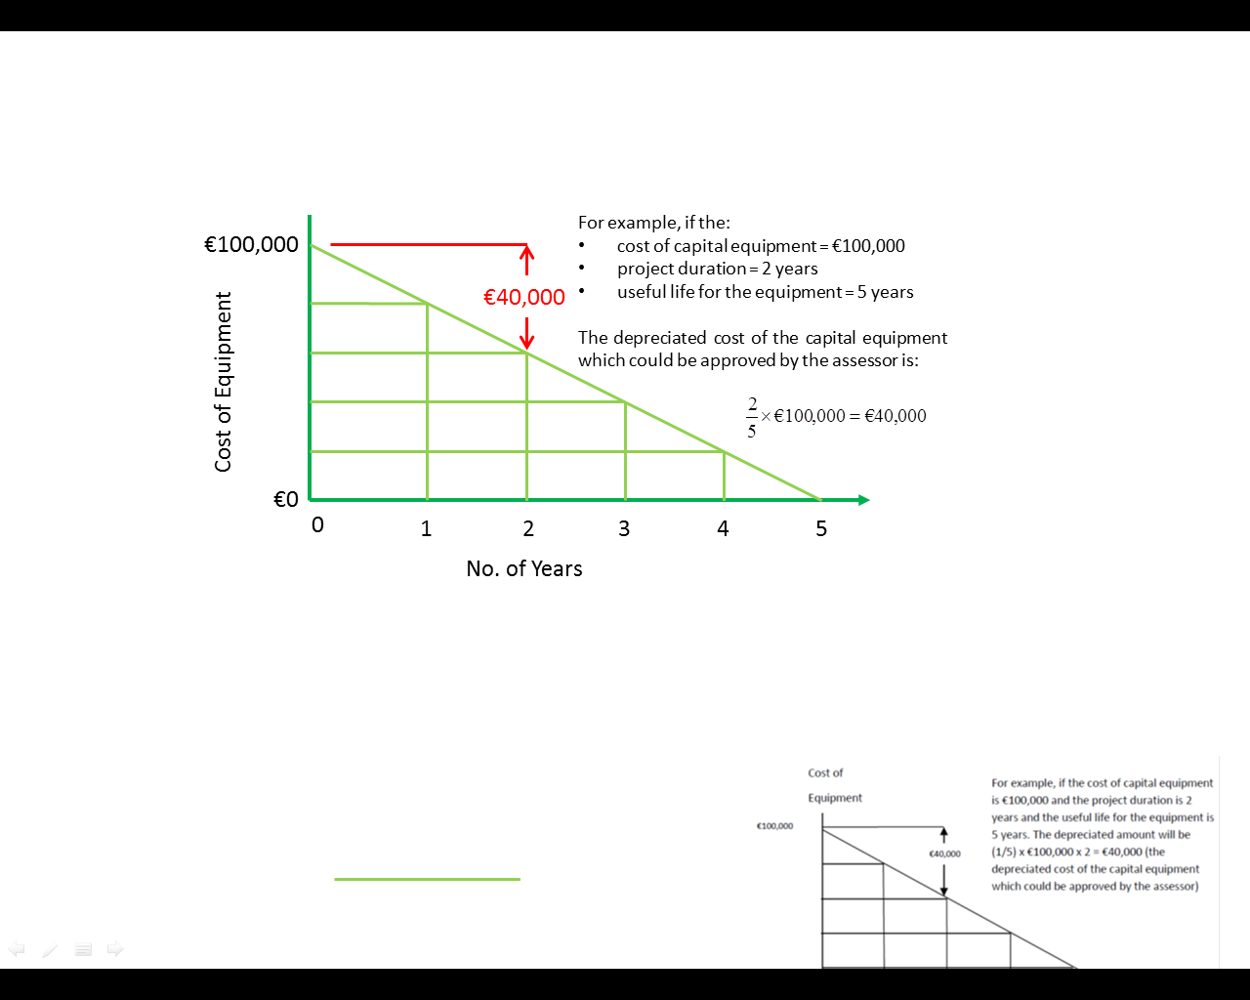

**Figure 3 - Diagrammatic representation of capital depreciation**

### Depreciation of ICT Capital Costs:

Equipment often includes computers and servers for an RD&I project but these must be justified as required for the RD&I. For ICT capital costs a shorter appropriate number of years to calculate depreciation is permissible e.g. 3 years.

## C: Costs of Buildings & Land

Costs of buildings and land, to the extent and for the period used for the project.

With regard to **buildings,** only the depreciated costs corresponding to the life of the project, as calculated on the basis of generally accepted accounting principles, are considered as eligible.

For **land,** costs of commercial transfer or actually incurred capital costs are eligible.

If the company has a formal depreciation policy agreed with its auditors, these figures may be used. Generally, buildings are depreciated over 20 years.

## D: Costs of contractual research, knowledge and patents, consultancy and equivalent services (e.g contract R&D)

Costs of contractual research, knowledge and patents bought or licensed from outside sources at arm's length conditions, as well as costs of consultancy and equivalent services used exclusively for the project can be included.

**Consultancy** costs (capped at 10% of eligible project expenditure) can be included if theyare required to bring in new skills/capability to the RD&I team in Ireland. It should be clearly demonstrated that this is a short-term measure. Only consultancy time spent in Ireland with the team is eligible; it cannot be used to fund part of the RD&I team elsewhere.

**Equivalent Services**:

Some level of **contract RD&I** staff based in Ireland working directly for the grantee company may be eligible, as long as there is a clear plan to bring the roles in-house.

**Contractual Research:** The cost to the company for availing of technical consultancy or contractual research from third parties (an individual, a company or a 3rd level organisation) is eligible in so far as it relates to the technical aspects of the development project.

Costs can be included for:

• Testing costs as part of the product/service development.

• Input from technical consultants.

• External consultant to help implement the RD&I project.

• Design Costs - Industrial design costs are normally considered an eligible cost as part of an overall development project.

The company must be able to make a clear distinction between the proposed design input and the normal routine design activity of the company (which are ineligible for support). The use of designers, either internal or external to the company, will be covered in these cases in so far as they relate to a specified RD&I programme.

• Funding towards market-led research/consumer focus panels is eligible where there is a clear requirement for the results to be used to develop the product/process which is the objective of the RD&I project. Projects consisting solely of market-led research/consumer focus panels/consumer reaction to products which are not integral to the RD&I project are not eligible**.**

**Certain Software Services**

Where a software license relates to specific software needed as background IP/baseline to be able to conduct the R&D project, e.g.,  for cloud or edge computing R&D projects, license fees for such software will be treated as falling under this heading – i.e. “costs of contractual research, knowledge and patents bought or licensed from outside sources at arm's length conditions, as well as costs of consultancy and equivalent services used exclusively for the project”.

**Note:**

* Training is not an eligible activity as part of an RD&I project.
* Original invoices for all consultancy will be required for grant claims. To ensure value for money it is suggested that clients seek three competitive submissions for consultancy assignments where the consultant’s fee is €25,000 or more – payment of grant is conditional on receipt of supporting documentation so that the inspection team can evaluate if the submission chosen represents value for money.
* Consultant costs should be a modest portion of the overall project costs (typically <10%). Further clarification will be required for unusually high levels of consultancy costs.
* All costs should be entered in Euros, if applicable the FX rate should be detailed under “rationale for cost estimate”.

## E: Additional overheads and other operating expenses (including materials supplies and similar products)

Additional overheads and other operating expenses, including costs of materials, supplies and similar products, incurred directly as a result of the project may be included.

The maximum permitted flat-rate figure for “overheads and other operating expenses (including materials supplies and similar products)” is now 20% of the eligible costs listed in (a) to (d) above.

### Treatment of Materials Costs

Materials can be included as a separate category of vouched eligible expenditure but, if that is done, the flat-rate figure of 20% referred to above cannot be claimed. In other words, there is now a choice between vouched “materials” as a category of eligible expenditure or the flat rate referred to above.

Materials costs are eligible in so far as they relate to the technical aspects of the development project. Enter the most accurate costings available for materials in the RD&I Project Costs Workbook. Quotations should be obtained. Indicate if quotations have been obtained or give a reason as to their absence.

Potential cost recovery must be taken into account and deducted from the project costs. This applies to materials for prototyping, either through the sale of prototypes or as scrap value or other residual value to the materials beyond the term of the RD&I project.

Production or operations materials are not eligible.

Note that original invoices for all materials will be required for grant claims.

The applicant is urged to consult with the relevant IDA Ireland Project Executive if the guidelines above do not include all aspects of a potential application.

# Intellectual Property Management

The RD&I grant supports in-house RD&I, as a result all intellectual property resulting from activities supported by this fund resides with the applicant company.

Note: A Tax Rate of 10% will apply to profits arising to certain Intellectual Property Assets which are the result of qualifying Research & Development activity carried out in Ireland. Consult with IDA Ireland for more information on the [Knowledge Development Box](http://www.idaireland.com/how-we-help/resources/infographics/knowledge-development-box/IDA_KDB.pdf).

# Repeat Applications

In the case of companies who have previously carried out State supported RD&I projects in the last seven years, the application must demonstrate either:

1. that there is an incremental increase in RD&I spend compared to the previous period; or
2. the expenditure relates to a strategic shift in RD&I for the company where the company is undertaking a significant risk in researching a fundamentally innovative and challenging technology new to the company but where there may not be a significant increase in spend compared to the previous period.

# EU State Aid

## Legal Basis

The legal basis will be the relevant sections of the [1986 Industrial Development Act](http://www.irishstatutebook.ie/eli/1986/act/9/enacted/en/html) and [1987 Science and Technology Act](http://www.irishstatutebook.ie/eli/1987/act/30/enacted/en/html).

## State Aid Basis

The State Aid basis for RD&I is the [COMMISSION REGULATION (EU) No 651/2014](http://eur-lex.europa.eu/legal-content/EN/TXT/PDF/?uri=CELEX:32014R0651&qid=1409130811330&from=EN) of 17 June 2014 declaring certain categories of aid compatible with the internal market in application of Articles 107 and 108 of the Treaty. [Framework for state aid for research and development and innovation](http://ec.europa.eu/competition/state_aid/modernisation/rdi_framework_en.pdf) (Brussels, 21.5.2014 C(2014) 3282) details state aid within the meaning of Article 107(1) of the treaty.

The Commission will consider an aid measure compatible with the Treaty only if it satisfies the following criteria:

1. *need for state intervention*: a state aid measure must be targeted towards a situation where aid can bring about a material improvement that the market cannot deliver itself, for example by remedying a **market failure**.
2. *incentive effect*: the aid must change the behaviour of the undertaking(s) concerned in such a way that it engages in additional activity, which it would not carry out without the aid or would carry out in a restricted or different manner or location.

## Demonstrating the Need for State Intervention

RD&I activities are characterised by a high degree of uncertainty. Under certain circumstances, due to imperfect and asymmetric information, private investors may be reluctant to finance valuable projects and highly-qualified personnel may be unaware of recruitment possibilities in innovative undertakings.

As a result, the allocation of human and financial resources may not be adequate and projects which may be valuable for society, or the economy may not be carried out. In certain cases, imperfect and asymmetric information may also hamper access to finance. However, imperfect information and the presence of risk do not automatically justify the need for state aid.

Projects with lower private returns on investments not being financed can very well be a sign of market efficiency. Moreover, risk is part of every business activity and is not a market failure in itself. However, in a context of asymmetric information, risk may exacerbate financing problems.

**1 of 3 – Commercial & Strategic Overview – Justification of Grant Aid.**

Comprehensive commentary on the need for state intervention must be provided in 1 of 3 – Commercial & Strategic Overview – Justification of Grant Aid. The cause of failure could be general regarding RD&I activity in the EU or specific to the particular EU industry sector. Examples of inhibitors to success include:

* High element of technical or commercial risk.
* Complexity of research proposed.
* High level of up-front investment required.
* Length of time to achieve break-even point.
* Difficulty in protecting research output e.g., IP protection.
* Difficulty in sourcing required finance from the market.

**2 of 3 – Technical Description of Project**

A comprehensive commentary on the degree of technical challenge and the technical uncertainties should be provided in form 2 of 3 – Technical Description of Project.

IDA and the technology assessor must take a view on the technical challenge that is presented by RD&I projects as this “degree of technical challenge” will be one of the criteria used to determine the level of grant support. The degree of technical challenge of a project is often influenced by the nature of underlying platform technologies employed. A complete description of these platform technologies is useful demonstrating how:

* the project represents a step up in capability by applicant; and
* the technologies can potentially underpin the development of a pipeline of products, services or processes.

In completing the section on uncertainties and technical risks in this form, consider whether the company faces uncertainty due to:

* First time technology has been employed in industry (uncertainty relating to utility/implementation).
* First time technology has been employed by the Company and/or by the Irish subsidiary and there is a lack of published data from competitors (uncertainty relating to implementation).
* First time this technology has been employed in the “field of use” by the industry (e.g., first time using this technology for a specific product/service/process).
* A unique and untried combination of novel technologies will be employed (combinatorial uncertainty).
* Need for the team to make significant changes/improvements/customisations to the technology to support development of new products/services/processes.
* Risk factors beyond scope of this project may limit return on investment from this project: Technology platform may be surpassed by another platform or Product/Service under development may not gain market acceptance/regulatory approval.
* Company undertaking a degree of open innovation – collaborating with outside partners with potential to lose some control of project and forfeit some ownership of foreground IP.
* First time that the Irish subsidiary has had responsibility for implementing the technology platform.
* Technology has been used before, but a significantly improved version exists and Irish subsidiary is seeking to assess its utility
* Technology has been used before but requires modification for a new area of application.
* Need for the Irish team to invest in research to make improvements to the technology platform and support improvements to products/processes.
* Factors beyond scope of this project may limit return on investment from this project e.g., Technology Platform may be surpassed by another platform or the Product/Service under development may not gain regulatory approval (if needed) or market acceptance.

## Demonstrating the Incentive Effect

An incentive effect occurs where the aid changes the behaviour of an undertaking in such a way that it engages in additional activities, which it would not carry out or it would carry out in a restricted or different manner without the aid. The aid must however not subsidise the costs of an activity that an undertaking would anyhow incur and must not compensate for the normal business risk of an economic activity.

**The Commission considers that aid does not present an incentive for the company wherever work on the relevant RD&I activity has already started prior to the aid application by the company to IDA Ireland. Where start of works takes place before the aid application is submitted by the company to IDA Ireland, the project will not be eligible for aid.**

**1 of 3 – Commercial & Strategic Overview – Justification of Grant Aid.**

The Incentive effect should also be demonstrated in in 1 of 3 – Commercial & Strategic Overview – Justification of Grant Aid. The company must show that the grant aid will result in at least one or more of the following.

* A material increase in the size of the project; or
* A material increase in the scope of the project; or
* A material increase in the total amount spent on the project; or
* A material increases in the speed of completion of the project.

**END OF DOCUMENT**

1. For applications involving B-2-B (Business to Business) collaborations please consult with your IDA Executive before initiating the application process to discuss process and options.
2. For collaborations that engage with SME’s (small medium sized enterprises) of indigenous origin, IDA Ireland’s sister agency Enterprise Ireland will be involved in the grant aid process as they hold the legal remit to support the indigenous component of the proposed RD&I activity. The B2B model proposed by the company will be discussed with the IDA Exec and the company will be advised on how to incorporate this activity into their RD&I application.